Structure of a Scientific Seminar
Remember, you will never be able to tell the full story.
Instead, you must select the pieces that are the most relevant.

- What’s the Problem? (Introduction and Motivation)
- What are You Doing? (Experiment and Method)
- What Have You Found and What Does It Means? (Results and Discussion)
- Take-Home Message (Conclusions and Future Work)
- Who Did and Paid for the Work? (Acknowledgements)
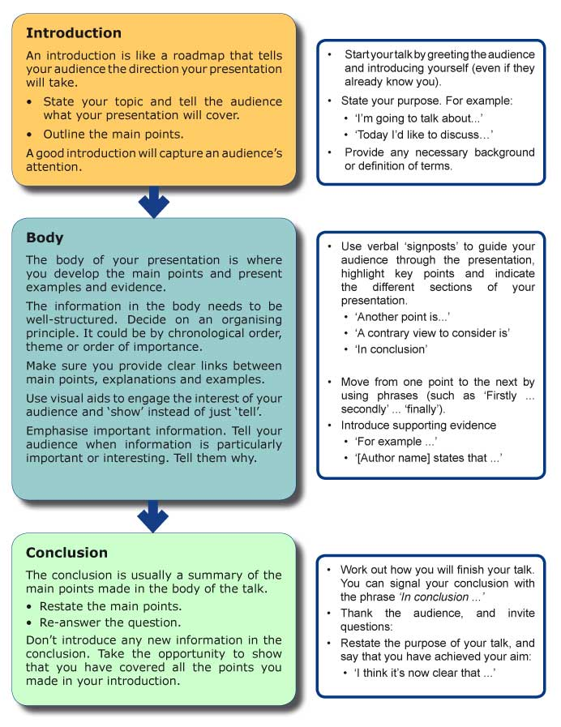
https://student.unsw.edu.au/support-oral-presentations

Tips for Speaking to an Audience
Many experienced speakers employ devices which give added effect to their speeches. Some of these are:

Foreshadow and Remind
An indication of what will be coming later in your talk is an effective method of maintaining audience interest. Use transitions to draw your audience a 'road map' of your talk. For example:
- In a few moments I will provide some statistics...
- There are four ways of understanding this. First - second - third - finally
- I'll now provide some evidence and examples to support my last statement.

Examples and illustrations
Use examples, anecdotes or verbal illustrations to interest and to suit your audience. An example that comes within the experience of the audience can create empathy and personal engagement.

When appropriate - ask questions and invite participation
Asking questions of your audience throughout your talk helps to maintain interest. It also develops a relationship between you and the audience.
Asking questions means that your words are not merely being aimed at the audience; you are inviting them to participate and drawing them into a mutual thinking process.

Eye contact
Make eye contact with your audience to establish a bond. Eye contact involves glancing at the faces or the members of the audience. Don't be afraid to look audience members in the eye, but don't stare continuously - a few seconds is enough.
Eye contact not only establishes a bond but also registers your progress. You can gauge audience reaction to what is being said by looking at the faces of the audience. Faces can indicate interest, puzzlement, boredom and pleasure. In other words, the faces of the audience are your barometer.

Pace
Speaking to an audience requires a slower pace than informal conversation. Pace can be varied: slow measured speech for a point which is serious or needs emphasis, faster speaking to lend excitement or urgency to other points. However, the pace should not be so slow that the audience becomes impatient to hear the next word.

Pitch
A low-pitched voice is pleasing to the audience and is comfortable for the speaker. Anyone’s voice can become higher due to shallow breathing and nervousness. Deep, steady breathing and a deliberate attempt to lower the pitch will help to reduce nerves.
Variations in pitch can be useful. For example, the pitch could be raised to add emphasis to a question. Variation needs to be employed with caution, as too frequent use of high pitch can irritate an audience.

Tone
Tone is the quality which expresses feeling. It can lend warmth and sincerity to your voice or reveal how strongly you feel about a topic. This can evoke a similar response from the audience.
In academic presentations a harshly critical, judgmental, or “know-it-all” tone should be avoided. It can make a speaker sound aggressive or biased.

Volume
High volume or loudness is not the same thing as shouting. The voice should only be loud enough for those listeners in the back rows to hear comfortably. You can vary volume to make the seminar more lively and interesting.

Pausing
Inexperienced speakers think of a pause as a failure in fluency, and try to avoid its use. Experienced speakers use pauses to great effect. Pausing can focus attention on what has been said or what is about to be said, or to prepare the audience for a change in ideas.

https://student.unsw.edu.au/speaking-audience
* Adapted from: Pitman, 1988, Business Communication.

And I would add:
Enunciate
As you practice and present, be conscious of expressing each word and idea to the audience. Speak as clearly as you can.

Preparation for your seminar

3-4+ weeks before seminar:
Start putting together your talk. Begin with an overall structure, objective for your talk, and objectives of your project (what you’re presenting). Consider your audience and what THEY will be looking for. Know your time allotment.

1-2 weeks before seminar:
Give a practice talk to yourself (and maybe 1-2 others) IN THE ROOM where you’ll present. Look at your own slides from the back of the room. Are they readable and pleasing? Practice projecting your voice to the back of the room. You will need to face the room in order to be heard. That means you need to know what is on your slides without needing to read each word.

1 week before seminar:
Give a practice talk to others. Make sure at least 3 people can attend. It is ok to have a few gaps in your presentation at this time, but it should be 95% ready – close enough that you can reasonably judge your timing. Can they hear you in the back of the room? Is anything unclear?

3-4 days before your seminar:
Make your last changes to the slides.
Identify 2 slides at approximately 1/3 and 2/3 through the talk, and your time target for these slides. You can use these to gauge your pace.

1-2 days before your seminar:
Relax. You’re prepared.
Go through your slides 1-2 times and practice the exact words you want to use. If there are repeated stumbling blocks, write yourself a FEW notes or notecards to remind yourself.
Eat wisely (low sugars, low alcohol). Stay hydrated.
Understand that you might be feeling anxious. Exercise, meditate, breathe deeply.

Day of seminar:
Look good. If you look good, you’ll feel good.
EAT, DRINK, and BREATHE. Eat something healthy in the morning, and again 1-2 hrs before seminar. Stay hydrated. Breathe.
Load your talk at least 15 minutes before your seminar. Click through every slide. This loads all the pictures and animations so they’ll come up more quickly during the talk.
Visit the restroom 10-20 minutes before your seminar.
If you tend to get a sore throat, have a cough drop 10-20 minutes before.
Make sure you have water for your talk.
Smile. You have something to say.

