SWD Overwintering and Life Cycle Strategies in the PNW

Beverly S. Gerdeman and Lynell K. Tanigoshi

WSU Mount Vernon Northwestern Washington Research & Extension Center

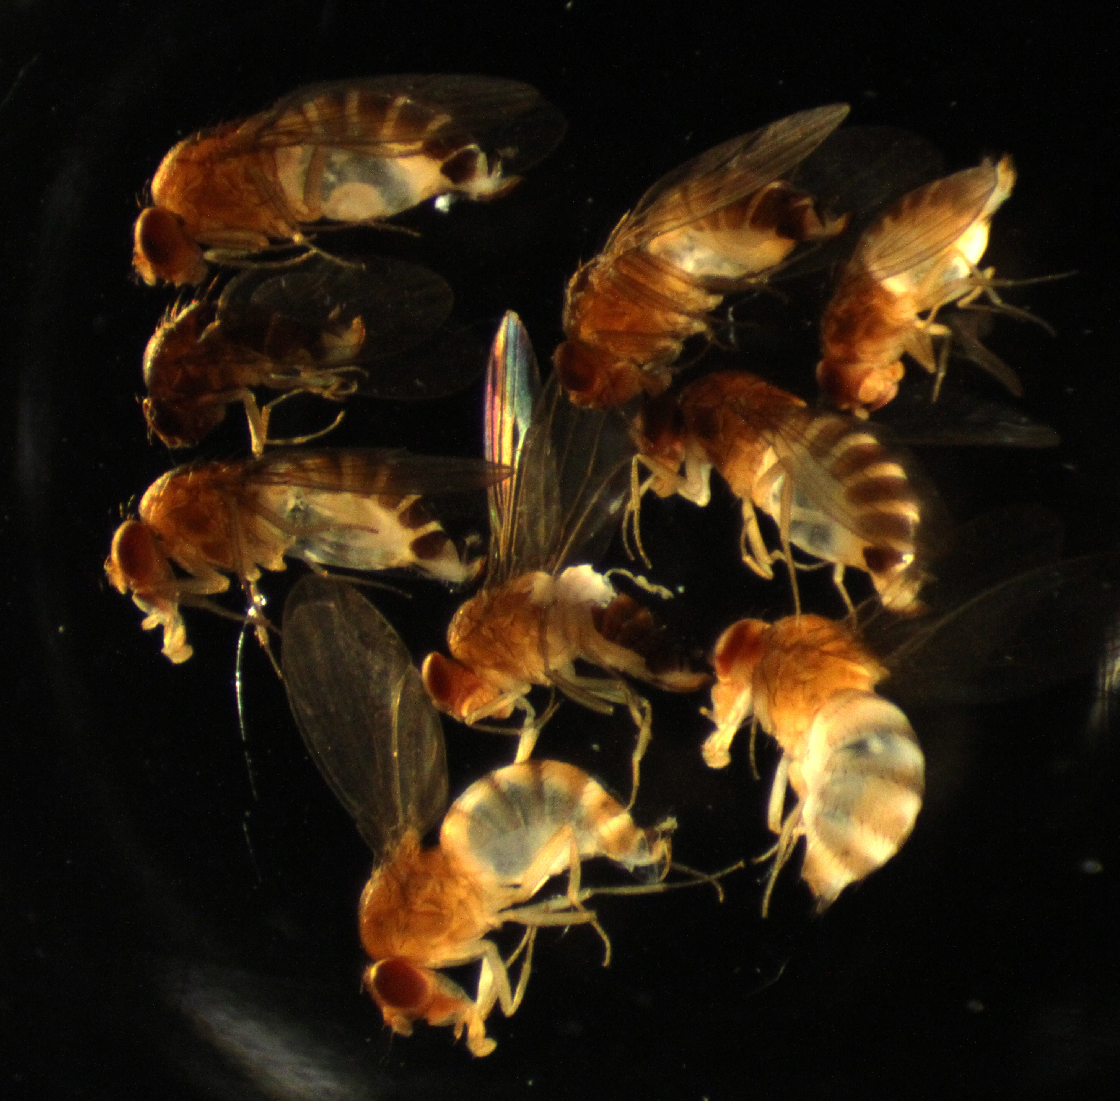
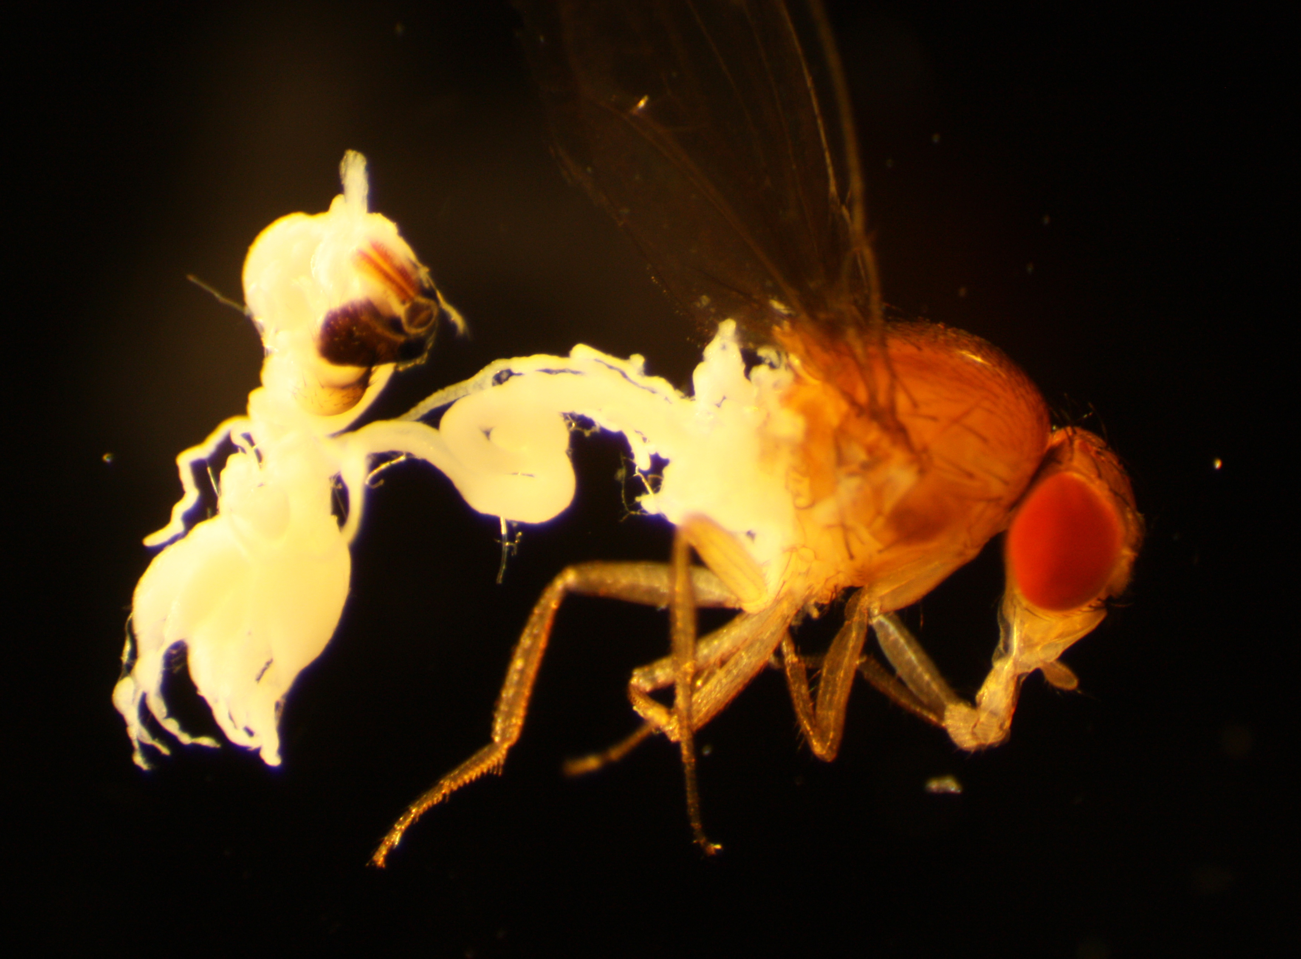
Spotted wing drosophila can be captured in traps year-round. Attractiveness to apple cider vinegar traps is independent of egg-laying ability, or oviposition. Dissections of female SWD help to answer questions of when they are capable of laying eggs and thus most destructive. Between 2010 and 2013, over two hundred female, field-trapped SWD from various crops were dissected. Observations of these females from every month of the year revealed seasonal differences in populations. Females in fall appear darker and larger. At this time they are shifting from the egg-laying form to an overwintering form. Cooler temperatures and shorter daylight trigger this shift. Short day length reduces the amount of the hormone required to produce eggs. Beginning in late September this process allows them to lay down fat and even withstand starvation and dehydration for months. This is evident in January when abdomens of both sexes appear eerily hollow (Fig. 1). Starvation has depressed the abdominal contents against the side of the abdominal wall. Nonviable eggs embedded in a thin sheet of fat can sometimes be observed in females that went into the overwintering phase with eggs still in the reproductive tract. Late spring dissections indicated feeding had begun and with it egg development. Viable eggs from dissected females representing 3 localities (Seattle, Skagit County and BC, Canada) were found from late May through September, coinciding with fruiting seasons in the Pacific Northwest (Fig. 2). Appearance of young adults still not hardened, from June – August and not again until late September, suggests the number of generations could be as few as three but extended egg-laying periods makes it difficult to separate distinct generations. The shift from the short-lived, reproductively active females in the summer, to the long-lived, overwintering females is gradual. Various aged females can be discerned early in the overwintering phase. Some are fertilized prior to winter and others are not. Undoubtedly not all survive the winter. While this research helps us understand how they can withstand months of starvation and cold temperatures, many questions remain. More dissections from many more localities will help support or challenge the above findings and determine latitudinal differences in their life cycle. Focus on dissections from a single location compared with another, may help determine if individual management practices promote adaptation and whether flies adapt differently from one field to the next or from one type of fruit to another. Their capacity to adapt and quickly evolve is not uncommon in drosophila species but it has made SWD the most challenging pest the Pacific Northwest small fruit industry has yet encountered and its most formidable foe to control.
Fig. 1. Near hollow bodies indicative of overwintering starvation mode in SWD adults.
Fig. 2. Dissected SWD shows ovaries with developing eggs appearing as small beads (far left), increasing in size and maturity as they pass down the ovariole prior to oviposition.

