How does the work of the  WSU Research Center connect to  my K-12 classroom teaching?  WSU Mount Vernon supports a diverse agriculture, including dairy and livestock industries, and the production of over 60 fresh-market and processing crops on approximately 100,000 + acres. Blueberries, red raspberries, strawberries; cabbage, spinach, table beet and 20+ other vegetable and grass seed crops; cucumbers, green peas, red and yellow potatoes, and specialty vegetables; apple and grape and other specialty fruit cultivars; tulips, daffodils and irises; turf, nursery and greenhouse crops; and, various small grain crops flourish here because of the rich soils and mild, marine climate.  Established in 1947, WSU Mount Vernon serves our agricultural and horticultural communities by successfully developing bio-degradable mulches, high tunnel systems, pest and disease control, and bio-fuel crops. Our $8M renovation project in 2006, including an Agricultural Research & Technology Building, is considered a model for revitalizing Research and Education Centers in the U.S.  We aim to connect science, economics, history, and STEM learning into our partnerships. By increasing K-12 teacher and student partnerships, we are growing the next generation of leading researchers.  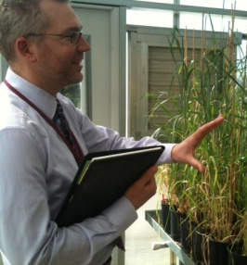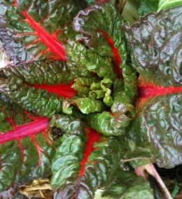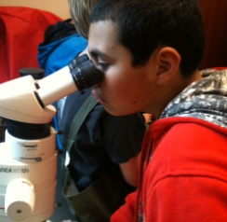  The K-12 Connection  We began planning this event by asking:  - How do we teach K-12 children the value of our region?  - What does Skagit Valley offer to farmers, bakers, and researchers?  - How can we use bread to teach physics, chemistry, biology, and botany?  Session Descriptions:  (All participants rotate through all sessions)  The Mill on the Skagit  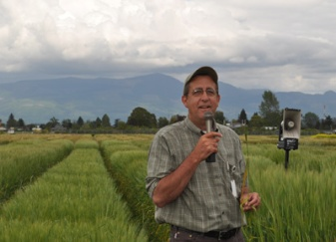  Skagit is known for tulips and berries, but many are unaware that this was once a vibrant wheat-growing area. In this session, Stephen Jones will use the “language of wheat” to help teachers learn more about how breeders are researching flour qualities such as yield, disease resistance, and protein content. Find out what Skagit varieties can provide – unique flavors that match the beauty and exceptionality of our region.  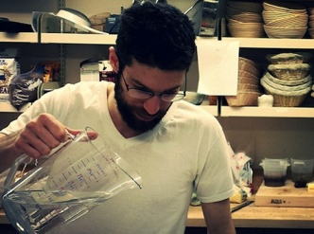  For the Love of Bread  Step into the Bread Lab to watch science and art coalesce into a perfect artisan baker-land. Jonathan McDowell will show teachers how 100% whole-wheat bread isn’t just edible, but delicious. Teachers will leave with recipes and tips – and a strong desire to return to the lab with their K-12 students. |  | WSU Researchers  Stephen Jones, director of WSU Mount Vernon, seeks to rebalance grain varieties in this region. He holds a PhD in Genetics from University of California Davis.  Steve Lyon leads the field research portion of the plant breeding group. Steve was a farmer and WSU researcher in Pullman before coming to Mount Vernon. Last year, WSU released a new barley called “Lyon” to honor his research. His current focus is Winter Wheat.  Jonathan McDowell works amidst the rich, toasty aroma of the WSU Bread Lab. He trials local grain varieties in non-conventional ways, varying hydration, temperature, and time to assists local bakers in finding desired dough qualities.  Louisa Winkler has moved from the United Kingdom to Mt. Vernon for her PhD research on oats. She is advised by Dr. Jones on his program of plant breeding for Western Washington.  The main objectives of WSU Mount Vernon are to solve plant-related problems, and develop cost-effective and environmentally-sound plant production practices based directly on results from experimental field, greenhouse and laboratory research trials.  Making New Varieties of Wheat  Why limit ourselves to current crops when we can make our own? Steve Lyon will show teachers how he cross-breeds crops that fit into diverse annual and perennial rotations on small and mid-sized farms. He will explain the important distinction between cross-breeding and genetically-modified. Participants will see connections between history, biology, and botany. Teachers will have the opportunity to emasculate a wheat plant in preparation for hybridization and weather permitting, observe real “science in the field”. This will be a fun and informal outdoor breakout session, rain or shine.  Nice to Eat You! Introducing the Oat  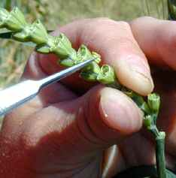  As the Skagit moved from a world of horses and steamboats to one of tractors and highways, oat production almost disappeared from the valley. In this workshop, we will have a chance to meet the oat plant and discuss how it is grown, before investigating what oats could bring to the Skagit Valley’s farms and its economy. We will also look at the biochemistry behind health claims which consumers see on oat products, such as “heart-healthy” or “cholesterol-lowering”. The aim is to cover a broad base of ideas which can be picked up for a range of classes including biology, chemistry, nutrition, history and economics.  Planning a Class Visit  Plan out the connections between your classroom and units of study. Pencil in a class field trip to the WSU Research Center so your students can have hands-on experiences with grains and the people who grow them. |  | CULTURE  of the land  Connecting K-12 Teachers to  the WSU Research Center  Join us Saturday, April 19th  9:00 a.m. – 2:30 p.m.  WSU Research Center  16650 State Route 536, Mount Vernon, WA  Try your hand at:  - Plant-breeding  - Milling wheat  - Baking bread  - Fermenting oats  Register by March 28th  $12 registration fee includes lunch  Open to K-12 teachers in Whatcom, Skagit, Snohomish  Due to space, we are limited to 50 participants  Registration Form:  First Name: ____________________  Last Name: ____________________  Address: ______________________  City/State/Zip: _________________  Phone: _______________________  Email: ______________________________________  School: _____________________________________  Grade level(s) & Subject(s) you teach: __________  To better serve specific teacher needs, please let us know why you are interested in attending this workshop:  Mail this form and your $12 check, payable to WSU Research Center to: 16650 Washington 536, Mt Vernon, WA 98273  4.5 clock hours will be available at the event,  at NWESD clock hour rate.

